Individualized Health Protocol
Student Name
Student DOB
ID Number
Grade
School

Student Specific Information:
- Student diagnoses
- Medications
- Significant side effects
- Emergency Medication
- Self-Management
- Supply location
- Included plans or procedures
- Important information or alerts

Disease Overview:
A seizure is a sudden, uncontrolled electrical disturbance in the brain that can cause temporary changes in behavior, muscle tones, motor coordination, movements, emotions, and level of consciousness. Seizure symptoms vary and can include a sudden change in awareness or full loss of consciousness, unusual sensations or thoughts, involuntary twitching or stiffness in the body or severe stiffening and limb shaking with loss of consciousness (a convulsion.)
There are two major classes or groups of seizures: focal onset and generalized onset.
Focal onset seizures start in one area and can spread across the brain and cause mild or severe symptoms, depending on how the electrical discharges spread.
Generalized seizures can start as focal seizures that spread to both sides of the brain. They also can occur as “generalized onset” seizures in which seizure activity starts simultaneously over both sides of the brain. Generalized onset seizures usually start during childhood and are similar to a thermostat surge or a light flash — abnormal regulation between parts of the brain causes the seizures.
Mayo Clinic ( 2022) Seizures. https://www.mayoclinic.org/diseases-conditions/seizure/symptoms-causes/syc-20365711

SEIZURE ACTION PLAN
IF… | THEN…
The student is falling, jerking, and/or stiff and rigid limbs: | - Assist the student to the floor; turn to side (preferably left side).  - TIME THE LENGTH OF THE SEIZURE  - Remove objects and clear furniture which may cause injury.  - Loosen restrictive clothing and remove eyeglasses.  - Place padding under the head.  - Delegate an adult to remove other students from the area.  - Allow seizure to run its course.  - DO NOT restrain the student.  - DO NOT insert anything into the student’s mouth.  - DO NOT try to stop purposeless behavior.  - Remain calm. Speak quietly and calmly to THE student and offer reassurance.  - ☒ Use VNS upon onset of seizure.  Refer to Procedure for Vagus Nerve Stimulator (VNS).
Student exhibits behavior outburst, lip smacking, head jerking, repetitive behaviors, and/or brief period of staring: | - Time the length of the seizure.  - Assist the student to a comfortable position.  - Speak quietly and calmly and offer reassurance.  - Reassure the other students in the area. Do not refer to the student as “having a spell”.  - DO NOT restrain the student. Avoid touching the student unless his/her safety is compromised.  - If student is acting angry or aggressive, stay back from student
Student exhibits any of the following, then an emergency response is required:  - Absent breathing and/or pulse  - Seizure lasts more than 5 minutes.  - 2 or more seizures without full recovery of consciousness between seizures  - Continued unusual paleness or bluish skin/lips.  - Noisy breathing after seizure has stopped.  - Significant injury sustained during the seizure, especially to the head or neck.  For seizures lasting longer than 5 minutes | - Delegate call to EMS/9-1-1 immediately.  - Delegate call to school nurse and parent.  - Start CPR for absent breathing or pulse.  [ ] Administer emergency medication, if ordered:  Midazolam 10 mg  Refer to Procedure for Intranasal Midazolam
Seizure is complete | - Reorient and reassure the student.  - Allow student to change into clean clothing if necessary. Allow student to sleep and rest as desired.  - A student recovering from a generalized seizure may manifest abnormal behavior such as incoherent speech, extreme restlessness, and confusion. This may last from five minutes to hours. The student is not responsible for his/her behavior during this period.  - Inform parents/guardian immediately of seizure via telephone if not previously notified.  - Ensure the nurse is notified of the incident.  Complete required documentation.

PROCEDURE FOR VAGUS NERVE STIMULATOR

- Student’s magnet(s) located:
- With student
- With teacher(s)
- In office
- Other: _________________________________________________
- If the student feels an onset of a seizure, the student may swipe the magnet independently. If the student exhibits seizure activity, designated staff will swipe on the student's behalf.
Instructions for How to Use the Magnet
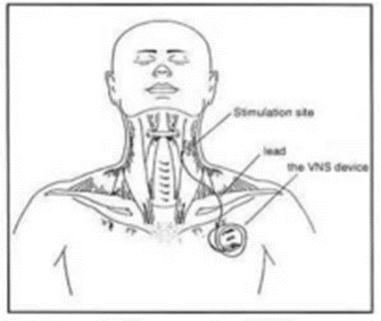
- Place the magnet over the VNS device located on the upper left side of the chest towards the clavicle. Look for a raised area where the device is placed.
- Hover the magnet over the device for the count of 1 second (1-1000) then remove. The magnet will turn off the generator if held over the VNS for six seconds or longer.
- The magnet should be passed again after 60 seconds if needed.
- This can be repeated up to 3 times.
- If seizure does not resolve after 3rd swipe:
- Prepare to administer midazolam
- Delegate calls to EMS ( 9-1-1), parent, RN
- Monitor airway and pulse

Epilepsy Foundation ( 2022) VNS. https://www.epilepsy.com/treatment/devices/vagus-nerve-stimulation-therapy
Giordano F, Zicca A, Barba C, Guerrini R, Genitori L. Vagus nerve stimulation: Surgical technique of implantation and revision and related morbidity. Epilepsia. 2017 Apr;58 Suppl 1:85-90. doi: 10.1111/epi.13678. PMID: 28386925.
Multnomah Education Service District ( 2016) Procedure for vagus nerve stimulator.
Image: Epilepsy.net

PROCEDURE FOR INTRANASAL MIDAZOLAM
For seizures lasting longer than 5 minutes, or cluster seizures of 3 or more over 60 minutes administer intranasal versed, per MD order.
Medication located: Main Office Health Room
Check fo the “5 R’s”
Right Student | First Name Last Name
Right Medication | Midazolam
Right Dose | 10 mg (2 ml)
Right Route | Intranasal
Right Time | For seizures lasting longer than five minutes
Right Documentation | Medication Administration Record

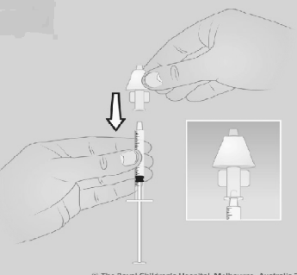
Equipment: Prefilled Syringe [Medication is pre-dosed and does not require drawing up] Procedure:
How to prepare the medication:
- Remove tip cap from midazolam syringe by twisting off, discard cap.
- Attach the atomizer to the syringe using a twisting motion. If needed, press the plunger to discard some medicine to get the prescribed TOTAL dose.
How to give the medication:
- If the student has a runny nose, clean the nose before giving the medicine.
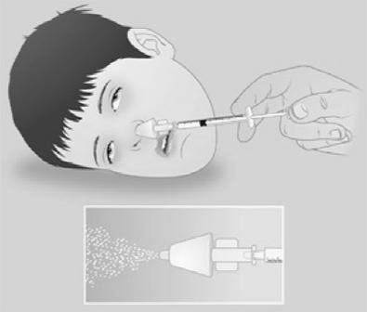
- Hold the student’s head steady with your free hand. Insert the head of the atomizer into one nostril snugly.
- Quickly press in the plunger to deliver HALF the dose into that nostril.
- Insert the atomizer head into the other nostril.
- Quickly press in the plunger to deliver the full syringe into the nostril.
Follow-up
- Any students receiving emergency medication at school should be dismissed to home with parent/guardian or transported by EMS.
- Ensure the nurse is notified of any seizure activity.
- Ensure appropriate documentation is completed for medication administration or incident reports.

The Royal Children’s Hospital(n.d.) Midazolam for Seizures. https://www.rch.org.au/kidsinfo/fact_sheets/Midazolam_for_seizures/
Mayo Clinic (2021) Midazolam ( nasal route). https://www.mayoclinic.org/drugs-supplements/midazolam-nasal-route/proper-use/drg-20463386#:~:text=Place%20the%20tip%20of%20the,spray%20unit%20only%20one%20time.
National Library of Medicine ( 2022). Midazolam Nasal Spray. https://medlineplus.gov/druginfo/meds/a621044.html

