Individualized Health Protocol - ASTHMA
Student Name:
Student DOB:
ID Number:
Grade:
School:

Student Specific Information:
- Student diagnoses
- Medications
- Significant side effects
- Emergency medication
- Self-Management
- Supply location
- Included plans or procedures
- Important information or alerts

Disease Overview:
Asthma is a common pediatric chronic disease and leading cause of school absenteeism. It is characterized by inflammation, narrowing of airways, and increased bronchial secretions.
Common symptoms may include:
- Coughing
- Wheezing
- Shortness of breath
- Chest tightness
Asthma includes a range of diseases with different severity, persistence, and triggers. Common triggers that exacerbate asthma symptoms include:
- Smoke
- Viral respiratory infections
- Exercise
- Gastroesophageal reflux
- Environmental allergens
- Certain medications
- Chemicals and fumes
- Emotional stress
- Obesity
- Chronic sinusitis
Hashmi MF, Tariq M, Cataletto ME. Asthma. [Updated 2021 Aug 14]. In: StatPearls [Internet]. Treasure Island (FL): StatPearls Publishing; 2022 Jan-. Available from: https://www.ncbi.nlm.nih.gov/books/NBK430901/

ASTHMA ACTION PLAN

At School:  ☐ Rescue Inhaler: ____________________________  ☐ Spacer  ☐ Nebulizer: ________________________________  ☐ Other Medication: ________________________  ☐ Peak Flow Meter  ☐ Incentive Spirometer | Asthma Severity: ☐ Mild ☐ Moderate ☐ Severe ☐ Intermittent ☐ Persistent
 | Asthma Triggers: ☐ Respiratory Illness ☐ Exercise ☐ Dust
 | ☐ Animals ☐ Environmental Allergens ☐ Smoke ☐ Acid Reflux ☐Mold/Mildew ☐ Stress ☐ Other:
 | Self-Management: Student ☐ Self Carries ☐ Self administers inhaler
Green Zone | GO!
Presentation:  - Breathing is good  - No cough or wheeze  - Can work/play easily  Peak Flow is between  _________and _________  80-100% of personal best |  | ☐ Take daily maintenance medications:  Medication How Much? When?
☐ Exercise Induced Asthma

Medication How Much? When?
Yellow Zone | CAUTION
Present Symptoms:  - “It’s hard to breathe”  - Coughing  - Wheezing  - Chest tightness  - Cannot play, work, or eat easily  - Increased fatigue  Peak flow is between  _________ and __________  50-79% of personal best |  | ☐ Take rescue medication:  ☐ Puffs of rescue inhaler
 |  | ☐ Nebulizer treatment of
 |  | ☐ Repeat inhaler or nebulizer after minutes, as needed
 |  | If symptoms are not improving after ________ treatments, contact ☐ RN ☐ Parent
Red Zone | EMERGENCY
Present Symptoms:  - “Very hard to breathe”  - Nostrils flaring  - Ribs are showing  - Medication is not relieving symptoms  - Lips or fingernails are gray or blue  - Cannot walk or talk  Peak flow is between  __________and __________  Below 50% of personal best |  | Take rescue inhaler NOW:  Medication How Much?
CALL NOW!
- EMS (9-1-1)
- RN
- Parents
Parents: __________________________________________
RN: ______________________________________________
PROCEDURE FOR METERED DOSE INHALER

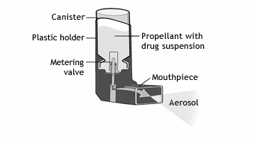
Procedure for Metered-Dose Inhaler: A metered-dose inhaler, called an MDI for short, is a pressurized inhaler that delivers medication by using a propellant spray.
- Identify when to use the inhaler per the Asthma Action Plan
- Review the 6 R’s to ensure that the student is taking the correct medication:

Right Student
Right Medication
Right Dose
Right Time
Right Route
Right Documentation
Check medication upon receipt and monthly. Advise parent immediately to replace medication two weeks before
expiration date. In an emergency, you may use expired medication.

To use an MDI:
- Shake the inhaler well before use (5 seconds)
- Remove the cap. If it has been 2 or more weeks since the inhaler has been used, prime the inhaler
- Ensure the student is standing or sitting straight up
- Advise the student to breathe out completely, away from the inhaler
- Bring the inhaler to the individual's mouth; advise the student to place it in the mouth between the teeth and close mouth around it
- Advise the student to start to breathe in slowly; press the top of the inhaler once and encourage continued breathing in slowly until a full breath has been taken
- Remove the inhaler from the student’s mouth, and advise them to hold their breath for about 10 seconds, then breathe out
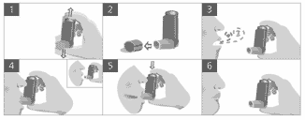
- If subsequent doses are needed, advise the student to wait 30 seconds to 1 minute and repeat the steps; document the administration on the medication administration record

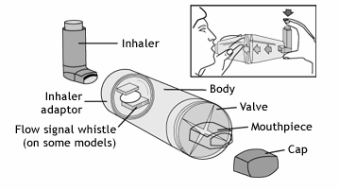
Procedure for Spacers
Also known as aerosol-holding chambers, add-on devices, and spacing devices, spacers are long tubes that improve the delivery of medication from pressurized MDIs. Spacers can make it easier for medication to reach the lungs, and also mean less medication gets deposited in the mouth and throat, where it can lead to irritation and mild infections.

To Use a Spacer:
- Shake the inhaler well before use (3-4 shakes)
- Remove the cap from the inhaler, and from the spacer if it has one
- Insert the inhaler mouthpiece into the spacer
- Advise the student to breathe out, away from the spacer
- Bring the spacer to the student’s mouth, put the mouthpiece between the teeth and advise the student to close their lips around it
- Press the top of the inhaler once
- Advise the student to breathe in very slowly until they have taken a full breath. If a whistle sound is heard, the individual is breathing in too fast. Advise the student to slowly breathe in.
- Advise student to hold their breath for about ten seconds, and then breathe out

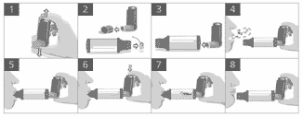

If subsequent doses are needed, repeat steps & document on medication administration record.

References

Moore, R (2022) Patient education: Asthma inhaler techniques in children ( Beyond the Basics). https://www.uptodate.com/contents/asthma-inhaler-techniques-in-children-beyond-the-basics?search=asthma-%20inhaler-techniques-in-adults-beyond-the-basics&topicRef=1172&source=see_link

Providence Health Home Services. (n.d.). Nebulized Medication Home Therapy Instructions.

Cleveland Clinic (2018) Home Nebulizer Treatments. Retrieved: https://my.clevelandclinic.org/health/drugs/4254-home-nebulizer
Adapted: Asthma Society of Canada

