Individualized Health Protocol
Student Name
Student DOB
ID Number
Grade
School

Student Specific Information:
- Student diagnoses
- Medications
- Significant side effects
- Emergency Medication
- Self-Management
- Supply location
- Included plans or procedures
- Important information or alerts

Disease Overview:
Anaphylaxis is a common acute hypersensitivity reaction that is potentially life threatening. Anaphylaxis is a rapidly progressively systemic allergic reaction that can lead to respiratory collapse and cardiac arrest. Anaphylaxis is characterized by:
- Skin symptoms such as itching, rash, redness hives, and significant swelling
- Respiratory symptoms such as shortness of breath, wheezing, persistent cough, intractable sneezing, impaired airway, low oxygen levels or throat clearing.
- Gastrointestinal symptoms such as persistent painful cramps or vomiting
- Low blood pressure
- Loss of consciousness
- Loss of bowel or bladder function
Triggers to anaphylaxis are many, and sometimes unidentified. The most common cases of anaphylaxis include:
- Foods, most specifically shellfish, nuts/peanuts, dairy, soy, eggs and fruits
- Insect venom, most specifically bees, wasps and yellow jackets
- Medications
- Latex
McLendon K, Sternard BT. Anaphylaxis. [Updated 2021 Dec 21]. In: StatPearls [Internet]. Treasure Island (FL): StatPearls Publishing; 2022 Jan-. Available from: https://www.ncbi.nlm.nih.gov/books/NBK482124/

Anaphylaxis Action Plan

☐This student also has asthma  *Students with asthma are at increased risk of severe reaction | Medication: ☐ Epinephrine ☐ Antihistamine ☐ Inhaler
 | Self-Management: Student ☐ Self Carries ☐ Self-administers epinephrine
UPON EXPOSURE TO KNOWN ALLERGEN
Known Allergens: | ☐ Observe for ________ following exposure to allergen or administration of antihistamine. | OR | ☐ Immediately administer injectable epinephrine:  ☐ 0.15 mg  ☐ 0.30 mg, per prescriber’s orders AND call EMS, Parents and RN
UPON ONSET OF MILD ALLERGY SYMPTOMS
Upon onset of mild allergy symptoms:  - Small localized rash or redness  - Mild itching at area of contact  - Eye irritation; watering, red eyes  - Nasal drip or congestion  - Intermittent sneezing | ☐ Administer antihistamine by mouth  How much: _____________________  Medication: ____________________, per MD order  ☐ Observe for worsening of symptoms for a total of _________ minutes following onset of symptoms or administration of antihistamine  - Prepare to administer epinephrine with onset of severe allergic symptoms  - Contact RN and parents if not previously contacted
UPON ONSET OF SYMPTOMS OF ANAPHYLAXIS
- Shortness of breath or chest tightness*  - Difficult/absence breathing*  - Continuous sneezing, wheezing, or coughing  - Difficulty swallowing*  - Swelling of eyes, lips, face, tongue, or elsewhere  - Dizziness and/or fainting*  - Rapid or weak pulse*  - Blueness around lips or eyelids*  - Sweating and anxiety  - Itching, rash or hives.  - Skin flushing or extreme pallor  - Hoarseness  - Sense of impending disaster or approaching death  - Involuntary bowel or bladder action  - Nausea, abdominal pain, vomiting, and diarrhea  - Burning sensation, especially face or chest  - Loss of consciousness  Note that not all symptoms may be present. Severity of symptoms can change quickly. | - Determine student’s symptoms are consistent with anaphylaxis  - Stay with student. DO NOT move person with symptoms of this severity (unless environment is hazardous).  - Have student sit or lie down.  - Immediately delegate calls to:  EMS/9-1-1, Nurse/Epinephrine trained staff, Parent  - Obtain Emergency EpiPen® (See Procedure for Epi-Pen administration)  - Administer Epinephrine:  ☐ 0.15 mg ☐ 0.30 mg injection, per order  ☐This student self-administers (if able).  - Note time of epinephrine administration  - ☐ Remove the stinger if present (for sting allergies). Rinse the affected area.  - Monitor symptoms for improvement and maintain airway.  - Administer CPR for absent breath or heartbeat  - Prepare to administer a second dose of epinephrine if symptoms are not improving within 5 minutes, and EMS is more than 10 minutes away.  - ☐ Administer (medication)_____________ (how much) _______________by mouth SUBSEQUENT to epinephrine administration only, per sorder  - Permit use of- or assist with administration of Metered Dose Inhaler for asthma.  - Advise EMS of symptoms and time of medication administration. Defer care to EMS. Student must receive medical care as soon as possible.  - Complete required documentation.  ♦This Anaphylaxis Action Plan requires ♦prescriber’s orders ♦ parent authorization ♦Training by a School Nurse♦ Completion of SAR Training with designated unlicensed assistive personnel

Procedure for Epinephrine Auto-injector

Follow directions to inject:
☐ | 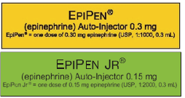 | Epinephrine 0.30 mg
☐ |  | Epinephrine 0.15 mg
- Note time of administration.
- Form fist around the auto-injector, orange tip pointing down.
- With your other hand, pull off the blue colored safety release.
- Place the orange end against the outer mid-thigh with or without clothing (only inject into the thigh, not buttocks, the injector is intended to go through clothing).
- Firmly push against the outer thigh until a click is heard.
- Hold firmly against the thigh for approximately 3-10 seconds to deliver the drug.
- Remove the unit from the thigh (the orange-colored needle cover will extend to cover the needle) and massage the injection area for 3 seconds.
- Epinephrine auto-injectors may be discarded.

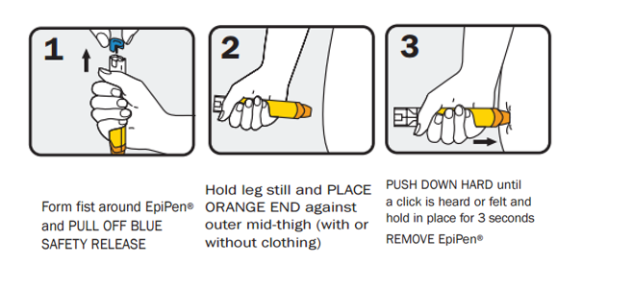

If a needlestick occurs during administration immediately notify supervisor and medical provider
Molalla River School District.(2021) Anaphylaxis Action Plan. https://www.molallariv.k12.or.us/departments/school_health_services/individual_school_health_protocols
Food Allergy Research & Education. (2022). Food allergy & anaphylaxis emergency care plan. https://www.foodallergy.org/living-food-allergies/food-allergy-essentials/food-allergy-anaphylaxis-emergency-care-plan
Oregon Health Authority. (2018). Epinephrine Training Protocol. Retrieved from http://public.health.oregon.gov/ProviderPartnerResources/EMSTraumaSystems/Pages/epi-protocol-training.aspx
Images: How to Use an EpiPen® (epinephrine injection) Auto-Injector. (n.d.). Retrieved from https://www.epipen.co

